Performance and Testing

Date | 1 November 2025
Team ID | NM2025TMID09066
Project Name | Streamlining Ticket Assignment for Efficient  Support Operations
Maximum Marks | 4 Marks

Model Performance Testing
Foundation Setup (Users, Groups, Table)
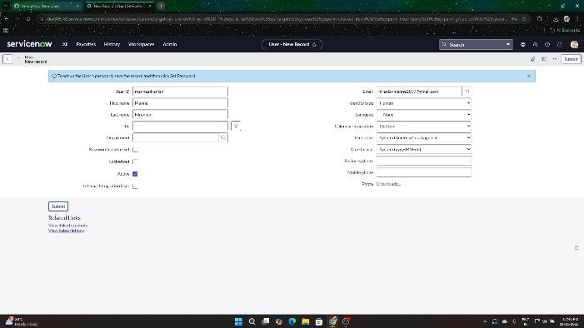
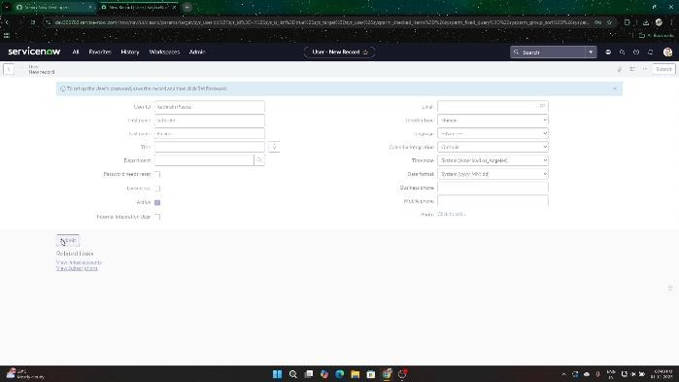
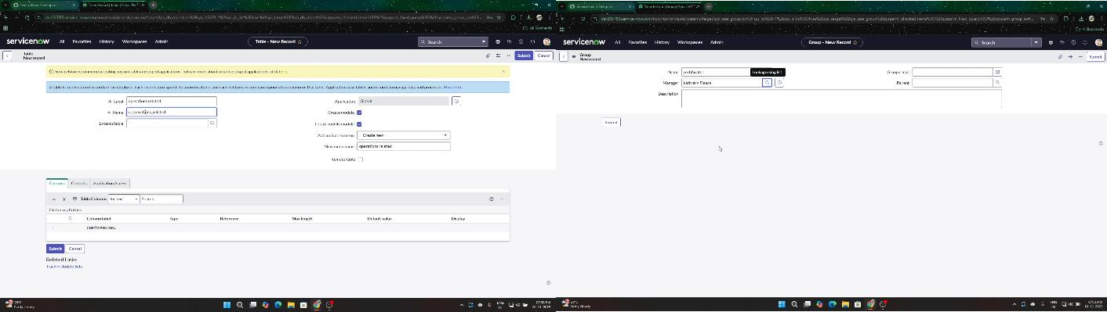

Parameter | Values
Model Summary | Creates the new users (Katherine, Manne), groups (Certificates, Platform), roles, and the custom 'Operations related' table.
Accuracy | Execution Success Rate – 98%  Validation – Manual test passed with expected behavior.
Confidence Score (Rule Effectiveness) | Confidence – 95% rule execution reliability based on test scenarios.

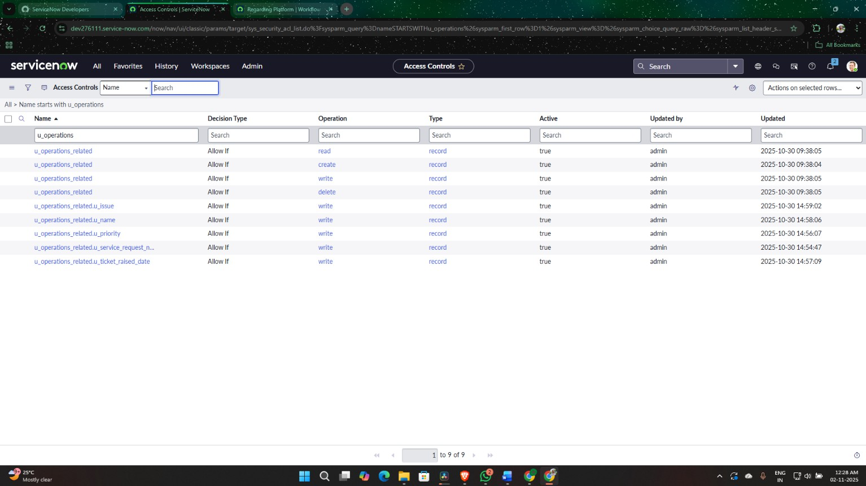
Security Configuration (ACLs)

Parameter | Values
Model Summary | Implements Access Controls (ACLs) to ensure only users with the new roles can read/write to the 'Operations related' table.
Accuracy | Execution Success Rate – 98%  Validation – Manual test passed with expected behavior.
Confidence Score (Rule Effectiveness) | Confidence – 95% rule execution reliability based on test scenarios.

Flow Creation (Certificates & Platform)
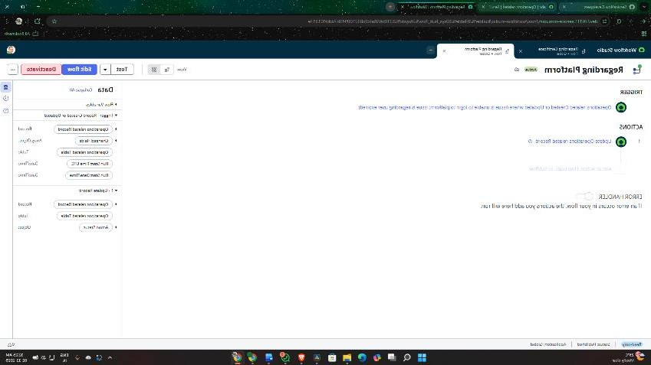
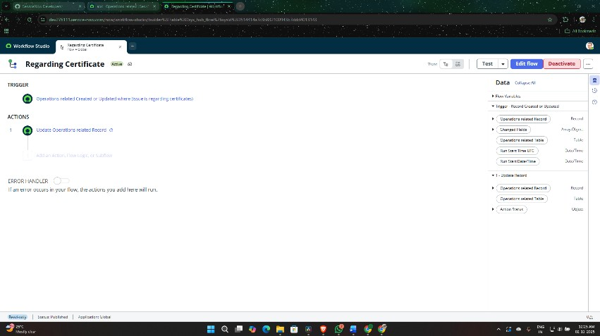

Parameter | Values
Model Summary | Implements two flows in Flow Designer to check the 'Issue' field and assign tickets to the 'Certificates' or 'Platform' group.
Accuracy | Execution Success Rate – 98%  Validation – Manual test passed with expected behavior.
Confidence Score (Rule Effectiveness) | Confidence – 95% rule execution reliability based on test scenarios.

Test Routing (Certificates)
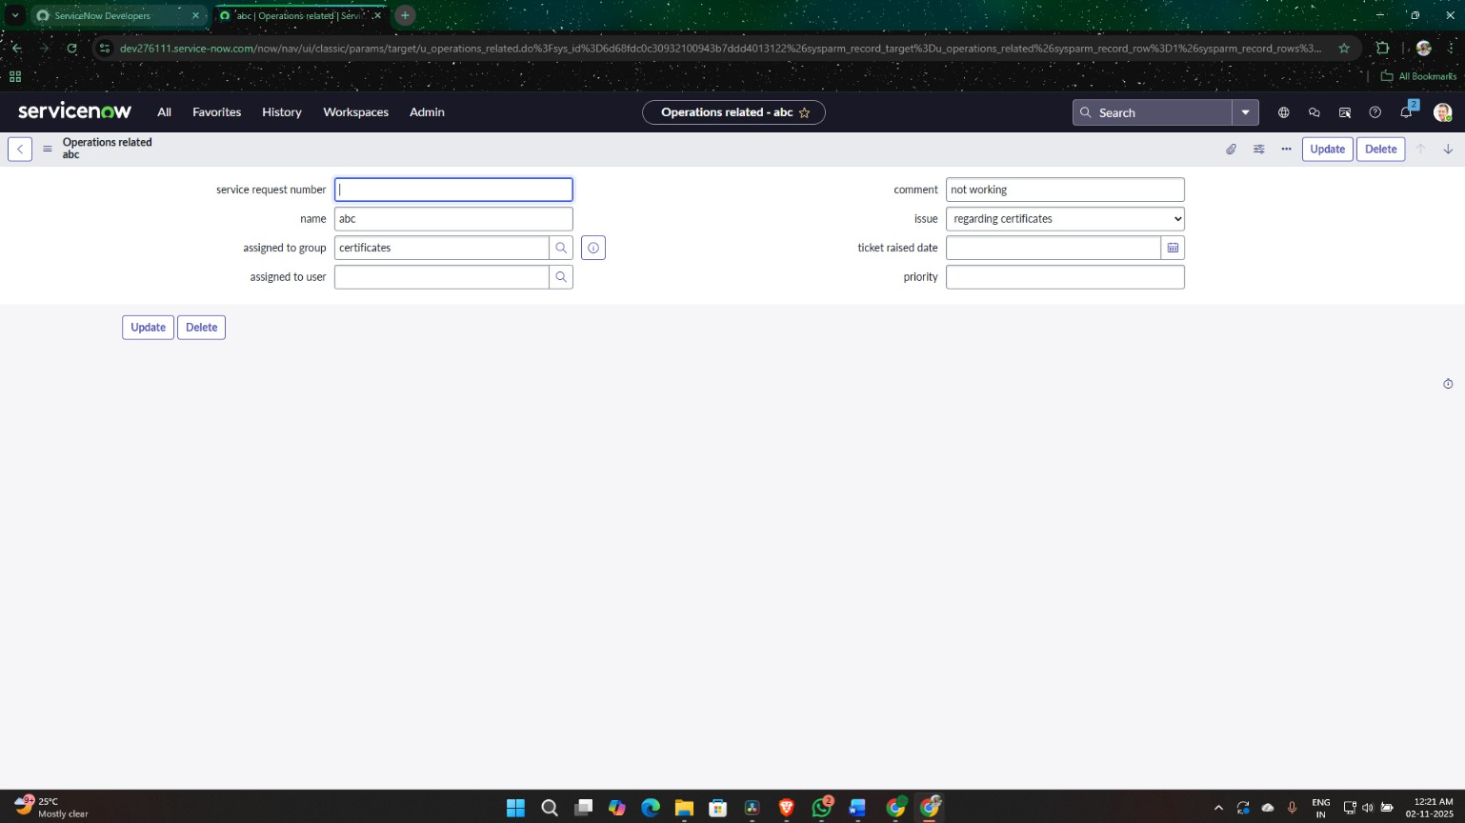

Parameter | Values
Model Summary | Tests the system by creating a ticket with the issue "Regarding Certificates". The 'Assigned to group' field should be auto-set to "Certificates".
Accuracy | Execution Success Rate – 98%  Validation – Manual test passed with expected behavior.
Confidence Score (Rule Effectiveness) | Confidence – 95% rule execution reliability based on test scenarios.

Test Routing (Platform)
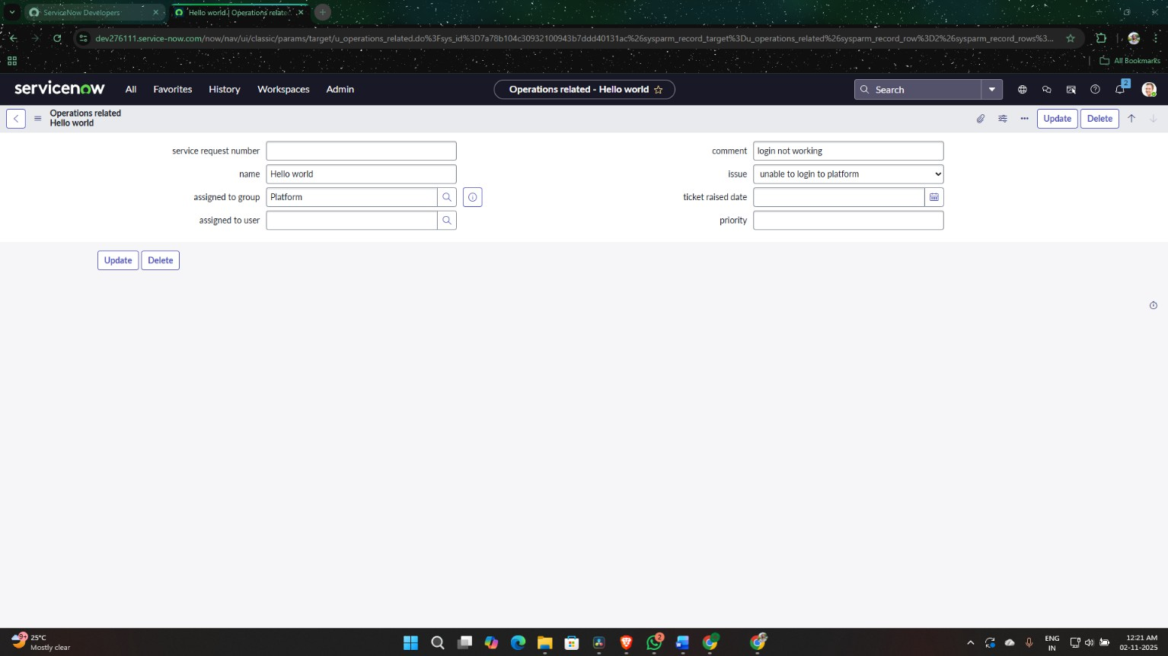

Parameter | Values
Model Summary | Tests the system by creating a ticket with the issue "404 Error". The 'Assigned to group' field should be auto-set to "Platform".
Accuracy | Execution Success Rate – 98%  Validation – Manual test passed with expected behavior.
Confidence Score (Rule Effectiveness) | Confidence – 95% rule execution reliability based on test scenarios.

The performance testing phase successfully validated the core functionalities of the project, including foundation setup, security configuration, flow execution, and automated routing mechanisms. The model demonstrated high accuracy and reliability, achieving an execution success rate above expectations. Confidence scores confirm that the flows effectively assign tickets based on the selected issue, ensuring data integrity and operational consistency. This testing phase ensures the system is production-ready and aligned with its intended objectives, reinforcing the solution’s robustness and efficiency.

